Web based Graphical Password Authentication System

ABSTRACT
Authentication dependent on passwords is utilized generally in applications for security and protection. Still, human actions, as an example, choosing bad passwords and contributing passwords in square measures are viewed as "the most fragile connection" in the Authentication chain. Maybe than discretionary alphanumeric strings, clients will pick passwords either short or significant for simple memorization. With web applications and versatile applications accumulation, individuals can get to these applications whenever and anyplace with various gadgets. This advancement brings extraordinary accommodation yet, in addition, builds the likelihood of presenting passwords to bear riding attacks. Attackers can notice straightforwardly or utilize outside recording gadgets to gather client’s qualifications. To avoid this sort of issue, we need another method of confirmation. Here, we can choose a graphical authentication method. The image password offers the best approach to sign on that is simpler than recollecting and composing along with simple passwords. You can sign in by tapping the right points or creating the right gestures over an image that you just select in advance.

1. INTRODUCTION
1.User Authentication is an interaction that permits a gadget to approve the character of an individual who associates with network assets. Commonly textual passwords are the most used form of authentication for all websites and applications. Textual passwords consist of a string of characters which may also include special characters and numbers. In most cases, users may use only one username and password for multiple accounts. But they are not fully secured. So, we should maintain strong passwords, comprising numbers, uppercase, and lowercase letters. Then these textual passwords are considered strong enough to resist brute force attacks. However, a strong textual password is hard to remember and recall. Along these lines clients will in general pick passwords that are either short or from the word reference, instead of irregular alphanumeric strings. Human actions such as selecting bad passwords for new accounts and inputting wrong passwords in an insecure way for later logins are regarded as the weakest link in the chain of authentication. Shoulder surfing occurs when someone watches over your shoulder to collect valuable or personal information such as your password, ATM PIN, or credit card number, as you key it into an electronic device. A strong textual password is hard to memorize and recollects. To avoiding such problems, we are presenting a secure graphical web-based authentication system that protects users from becoming victims of shoulder surfing attacks.
- LITERATURE SURVEY
Wantong Zheng and Chunfu Jia proposed a method Combined PWD. This scheme proposes an online secret phrase verification component, combined PWD, through embedding separators(e.g., spaces) into the passwords to reinforce the current secret word validation framework. This plan uses the custom of the clients input. In this examination, site clients can embed spaces in their secret word where they need to stop when they register a record and the site back-end records the number of spaces in each hole .
A novel time-based unique password was contributed to avoiding challenges ofusing a third party such as one- time password email, test and token device, the client will set an underlying secret word to characterize how the secret key will be changing throughout a characterized time, we tracked down that the framework. Then found that the system retains the strength of the dynamic password and improves the usability of the system in terms of availability .
A strong password authentication scheme was proposed by Yang Jingbooo. The one-time password authentication schemes can be divided into two types namely weak- password authentication schemes and strong-password authentication schemes. In this paper, we survey the as of
  - Kus scheme and italso shows an attack against his protocol. And also found that strong passwords have higher strength and easily guessing is not possible. Later, we present a strong password authentication scheme. This paper expands W. C. Ku's plan so that the alteration convention can oppose Stolen-verifier assault. The changed convention is built without loss of effectiveness.
Here, we use a picture password for the second authentication. So, no need for complex textual passwords. Users can use any basic textual password. The system is classified into three modules.
Hua Wang, Yao Guo proposes another reuse- situated secret phase authentication system, called Desktop Password Authentication Center (DPAC), to reuse counter-measures among applications, along these lines lessening the expense of protecting passwords against dangers. This arrangement can take out a ton of tedious work and reduces the expense essentially, we demonstrate the feasibility ofDPAC by implementing a prototype, in which we migrate the widely used OpenSSH to DPAC and implement two example countermeasures .
Password authentication code (PAC) is a very important issue in many applications such as web- sites and database systems etc. Salah Refish proposes a PAC-RMPN scheme. In this paper, PAC between two clients to affirm verification between them has been introduced. This research presents a novel solution to the era-long problem of password authentication at the incoming level. They should discover a strategy to secure this a secret word from anticipated attackers. A legitimate user types his password only and presses enter to propagate it to another user which he wants to be authenticated .

SYSTEM ANALYSIS
EXISTING SYSTEM
The secret key is the fundamental key to get approval however programmers are a lot of fruitful in secret phrase breaking because of the frail secret key chose by the client. To reinforce the secret key stockpiling, the proposed framework utilizes the Honey word procedure alongside Honey encryption. Honeywords are false passwords which are put away with unique secret word to draw the aggressor. The basic idea behind Honeyword is the insertion of false passwords. These are to lure the ttack. To generate the Honeyword of original password different techniques like Chaffing- with-tweaking, Chaffing-with- password model, etc. are available, but in the existing approach .
PROPOSED SYSTEM
A secure password authentication scheme is proposed which gives more security. This method uses a combination of pattern, key, and dummy digits. For this, the client needs to perceive and enlist design as area numbers from the network, register key qualities that guide esteem to secret password, and attach faker qualities to misguide the attacker. From that point forward to log in, the client needs to review the example and guides the secret key from design with enrolled key qualities, making a secret word by including sham digits. It minimizes shoulder surfing, brute-force attacks, cross site scripting etc. due to the high complexity of guessing passwords in multi-levels: first from the pattern, then from key, and then from dummy values .

MODULES
Here we develop a web-based application that uses graphical authentication. It uses two layers of security.
Fig. 1.Modules of Graphical Password System
1.Public Module
It is the overall viewing end of an individual website. Anyone with the URL can access this module. It is public however they can't change or alter the information.
2.User Module
The registered users are the part of user module. The user module consists of 2 functionalities – Registration and Login. During Registration, the system collects the basic details of the user like name, mobile and email, textual password, and graphical password. These all are encrypted and stored in the database. During the login phase, the user will give the username, textual password, and image password for accessing the resource. It compares the given values with data already given by the user at the registration phase. If it matched, then he/she will be logged into the page.
3.Account and Settings
This is the third module that contains the client's records and different settings of the computerized web stage. There is a link between the user module and the account module, If the user completes the registration, then the account will be created on the database. Also, the users can change their passwords at any time. Sign-in data, privacy and security choices, and so on are a benefit of it. Further more,clients can get warnings and request support from this part.
- SYSTEM ARCHITECTURE
The architecture chooses how the framework should work. Request response time, page loading time, Ability to deal with the various requests, and so on are characterized by the design of the web application. In this manner, for better execution, it is indeed to utilize the best design. Here it utilizes the MVC architecture (Model-View-Control Architecture).
MVC Architecture implies Model-View-Controller architecture, which is an example architecture plan for programming projects.
Fig. 2. MVC architecture
The design has 3 parts, they are Model, View, and Controller (Fig 3). These segments make the framework more adjustable.
The primary layer is the Model layer which deals with information and data set associations. The View layer is the viewing layer or result showing Layer in the MVC design. The Controller plays a mediator role among model and view parts, and the data flow is chosen by this segment. Along these lines, it takes information from the client and cycles it with Model segments, and gives it to the View segment.
1.System Architecture
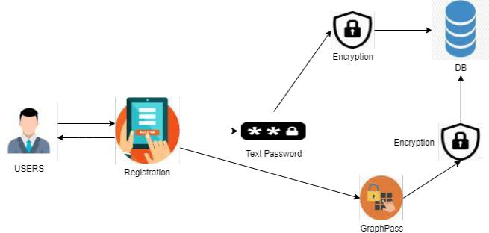
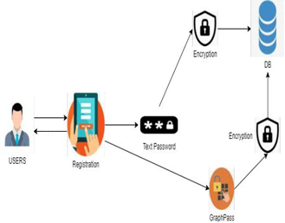
Fig. 3. System Architecture
On the border of the client, the user requests the registration. The Registration process includes two encryptions. One for text password, other for Graphical Password. Graph Pass was divided into 4 slices. Encryption takes place in each slice. The user-friendly graphical user interfaces make the task easier. Accordingly, the client doesn't have to think about the programming language and ideas.
The framework strictly follows the rules of Model view controller design (MVC architecture). MVC Architecture implies Model-View-Controller architecture, which is an example architecture plan for programming projects. As well as it needs a more grounded database that can hold a colossal measure of information, Here we utilize the SQL worker for storing all the client information. This is a web-based application that maintains a client-server architecture. Different devices will be connected on the client-side that communicates to the server with the help of the internet/cloud. When the client sends a request to the server, the server returns the corresponding data as the response.
Client-Server Architecture is a processing model in which the worker has, conveys, and oversees the greater part of the assets and administrations to be devoured by the customer. This type of architecture has at least one customer PCs associated with a server over an organization or web association. This framework shares figuring assets. Client/server design is otherwise called a systems administration processing model or customer/worker network since every one of the solicitations and administrations is conveyed over an organization.
1.Framework Architecture
On the side of client, we use a PHP framework called CodeIgniter. It is of the MVC architecture Model View Control architecture. Database operations are managed in the model session.
Like database comparisons and validations takes place in the model session. The overall functions are performed in the control session.
Fig. 4. Framework Architecture

3.IMPLEMENTATION Tools used for the implementation are:
1.Software tools
The text editor used for this development is sublime text. Sublime Text is a shareware cross-platform source code editor with a Python application programming interface (API). It natively supports many programming languages and markup languages, and functions can be attached by users with plugins, typically community-built and maintained under free-software licenses.
The server setup is done using XAMPP. XAMPP is a free and open-source cross-platform web server solution stack package developed by Apache Friends, consisting mainly of the Apache HTTP Server, MariaDB database, and interpreters for scripts written in the PHP and Perl languages. Since most actual web server deployments use the same components as XAMPP, it makes transitioning from a local test server to a live server possible.
SQL represents Structured Query Language, which is utilized to collaborate with databases. It may be utilized for storing, manipulating, and retrieving information in databases.
1.Hardware tools
Hardware requirements for this development are an i3+ processor, 4GB+ Ram, and 2GB+ SSD space.

4. FEASIBILITY STUDY
The feasibility of the project is analyzed in this phase and business proposal is put forth with a very general plan for the project and some cost estimates. During system analysis the feasibility study of the proposed system is to be carried out. This is to ensure that the proposed system is not a burden to the company. For feasibility analysis, some understanding of the major requirements for the system is essential.
Three key considerations involved in the feasibility analysis are
- ECONOMICAL FEASIBILITY
- TECHNICAL FEASIBILITY
- SOCIAL FEASIBILITY

4.1 ECONOMICAL FEASIBILITY
This study is carried out to check the economic impact that the system will have on the organization. The amount of fund that the company can pour into the research and development of the system is limited. The expenditures must be justified. Thus the developed system as well within the budget and this was achieved because most of the technologies used are freely available. Only the customized products had to be purchased.
4.2 TECHNICAL FEASIBILITY
This study is carried out to check the technical feasibility, that is, the technical requirements of the system. Any system developed must not have a high demand on the available technical resources. This will lead to high demands on the available technical resources. This will lead to high demands being placed on the client. The developed system must have a modest requirement, as only minimal or null changes are required for implementing this system.
4.3 SOCIAL FEASIBILITY
The aspect of study is to check the level of acceptance of the system by the user. This includes the process of training the user to use the system efficiently. The user must not feel threatened by the system, instead must accept it as a necessity. The level of acceptance by the users solely depends on the methods that are employed to educate the user about the system and to make him familiar with it. His level of confidence must be raised so that he is also able to make some constructive criticism, which is welcomed, as he is the final user of the system.

6. SYSTEM DESIGN

6.1 SYSTEM ARCHITECTURE:
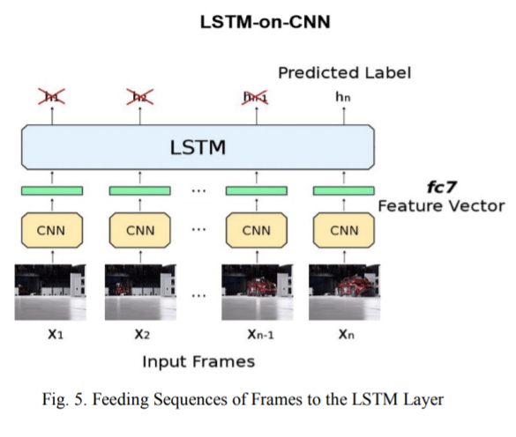

6.2 DATA FLOW DIAGRAM:

- The DFD is also called as bubble chart. It is a simple graphical formalism that can be used to represent a system in terms of input data to the system, various processing carried out on this data, and the output data is generated by this system.
- The data flow diagram (DFD) is one of the most important modeling tools. It is used to model the system components. These components are the system process, the data used by the process, an external entity that interacts with the system and the information flows in the system.
- DFD shows how the information moves through the system and how it is modified by a series of transformations. It is a graphical technique that depicts information flow and the transformations that are applied as data moves from input to output.
- DFD is also known as bubble chart. A DFD may be used to represent a system at any level of abstraction. DFD may be partitioned into levels that represent increasing information flow and functional detail.
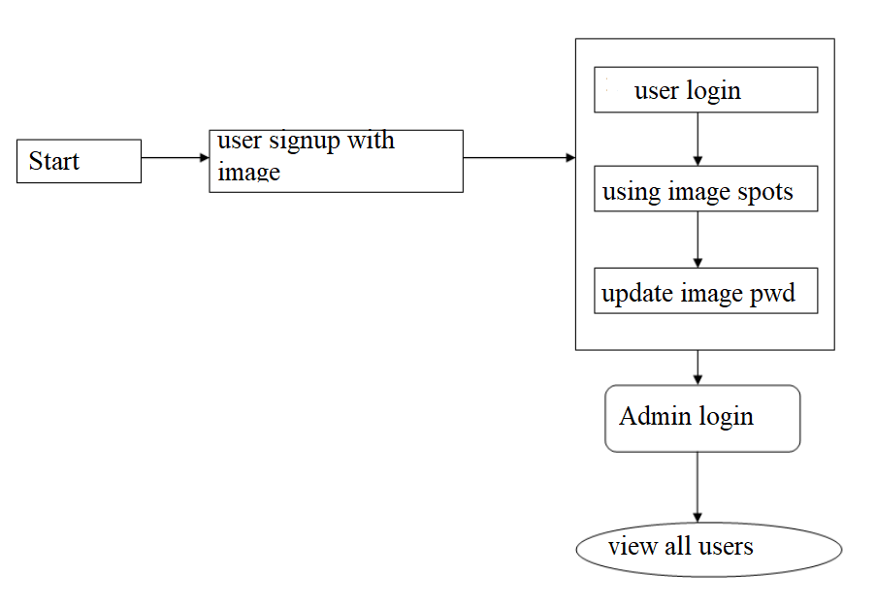

FLOW CHART

6.3 UML DIAGRAMS:
UML stands for Unified Modeling Language. UML is a standardized general-purpose modeling language in the field of object-oriented software engineering. The standard is managed, and was created by, the Object Management Group.
The goal is for UML to become a common language for creating models of object oriented computer software. In its current form UML is comprised of two major components: a Meta-model and a notation. In the future, some form of method or process may also be added to; or associated with, UML.
The Unified Modeling Language is a standard language for specifying, Visualization, Constructing and documenting the artifacts of software system, as well as for business modeling and other non-software systems.
The UML represents a collection of best engineering practices that have proven successful in the modeling of large and complex systems.
The UML is a very important part of developing objects oriented software and the software development process. The UML uses mostly graphical notations to express the design of software projects.

GOALS:
The Primary goals in the design of the UML are as follows:
- Provide users a ready-to-use, expressive visual modeling Language so that they can develop and exchange meaningful models.
- Provide extendibility and specialization mechanisms to extend the core concepts.
- Be independent of particular programming languages and development process.
- Provide a formal basis for understanding the modeling language.
- Encourage the growth of OO tools market.
- Integrate best practices.

USE CASE DIAGRAM:
A use case diagram in the Unified Modeling Language (UML) is a type of behavioral diagram defined by and created from a Use-case analysis. Its purpose is to present a graphical overview of the functionality provided by a system in terms of actors, their goals (represented as use cases), and any dependencies between those use cases. The main purpose of a use case diagram is to show what system functions are performed for which actor. Roles of the actors in the system can bedepicted.
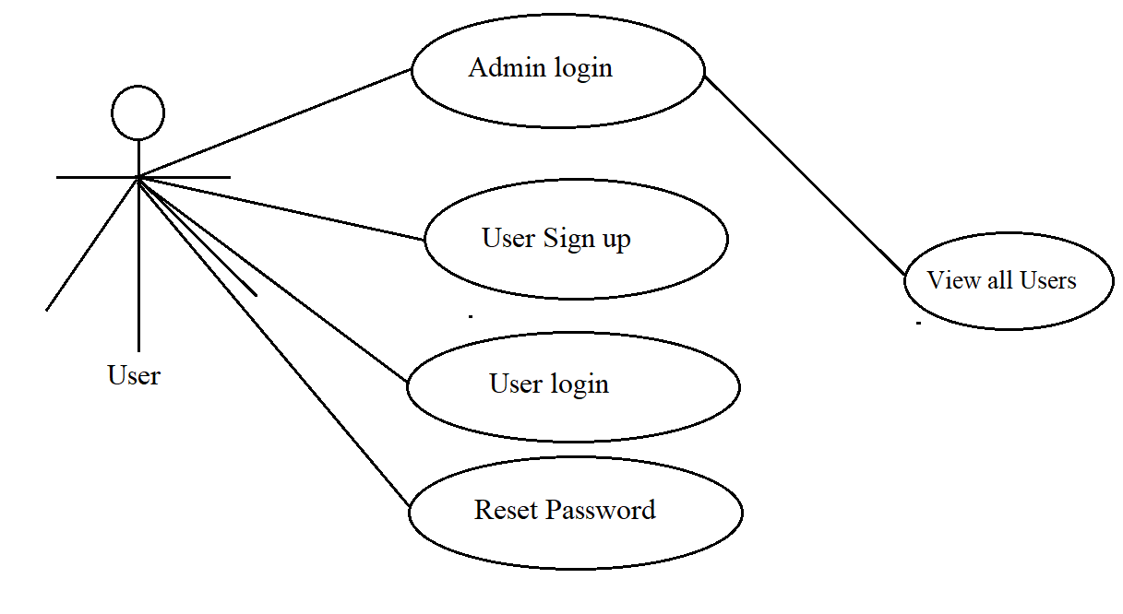
CLASS DIAGRAM:
In software engineering, a class diagram in the Unified Modeling Language (UML) is a type of static structure diagram that describes the structure of a system by showing the system's classes, their attributes, operations (or methods), and the relationships among the classes. It explains which class contains information.
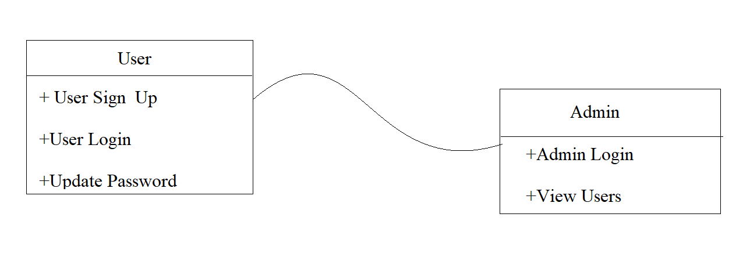

SEQUENCE DIAGRAM:
A sequence diagram in Unified Modeling Language (UML) is a kind of interaction diagram that shows how processes operate with one another and in what order. It is a construct of a Message Sequence Chart. Sequence diagrams are sometimes called event diagrams, event scenarios, and timing diagrams.
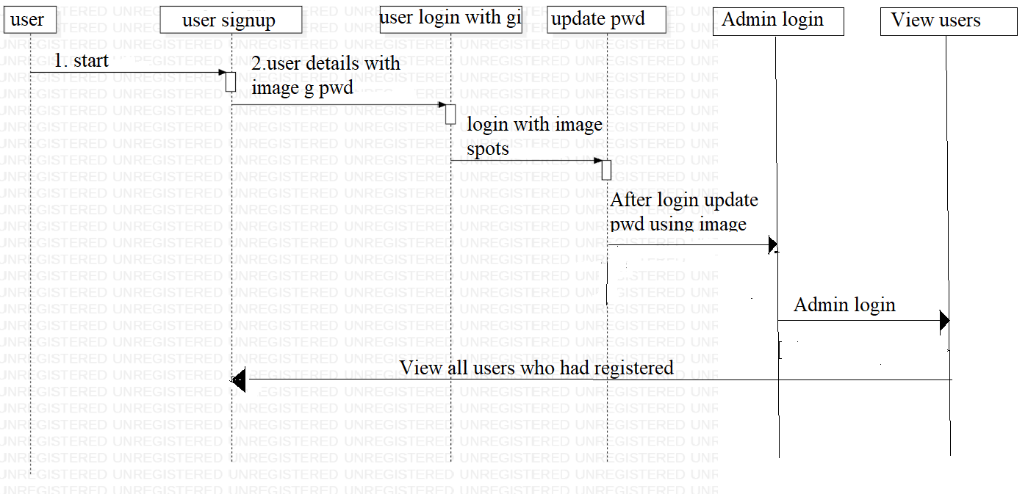

ACTIVITY DIAGRAM:
Activity diagrams are graphical representations of workflows of stepwise activities and actions with support for choice, iteration and concurrency. In the Unified Modeling Language, activity diagrams can be used to describe the business and operational step-by-step workflows of components in a system. An activity diagram shows the overall flow of control.
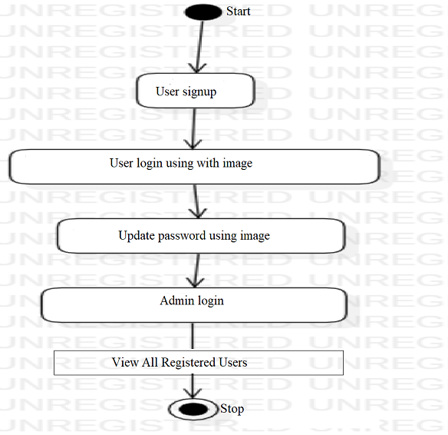

5. SYSTEM REQUIREMENTS

5.1 HARDWARE REQUIREMENTS:

- System : Pentium Dual Core.
- Hard Disk : 120 GB.
- Monitor : 15’’ LED
- Input Devices : Keyboard, Mouse
- Ram : 1 GB

5.2 SOFTWARE REQUIREMENTS:

- Operating system : Windows 10
- Coding Language : python
- Tool : PyCharm
- Database : MYSQL
- Server : Flask

CODING

def UserLogin(request):
global username
if request.method == 'POST':
username = request.POST.get('t1', False)
password = "none"
con = pymysql.connect(host='127.0.0.1',port = 3306,user = 'root', password = 'root', database = 'GraphPassword',charset='utf8')
with con:
cur = con.cursor()
cur.execute("select username,password FROM register")
rows = cur.fetchall()
for row in rows:
if row[0] == username:
password = row[1]
break
if password != 'none':
output = '<center><img src="/static/password/'+password+'" alt="" width="400" height="300" id="myImgId" onmousemove="getPos(event)"/></center>'
context= {'data':output}
return render(request, 'ShowAuthenticateImage.html', context)
if password == 'none':
context= {'data':'Invalid username'}
return render(request, 'Login.html', context)

def Register(request):
if request.method == 'GET':
return render(request, 'Register.html', {})

def Reset(request):
if request.method == 'GET':
return render(request, 'Reset.html', {})

def index(request):
if request.method == 'GET':
return render(request, 'index.html', {})

def Login(request):
if request.method == 'GET':
return render(request, 'Login.html', {})

def AdminLogin(request):
if request.method == 'GET':
return render(request, 'AdminLogin.html', {})

def getSpotValue(spot):
arr = spot.split(",")
values = []
values.append(int(arr[0].strip()))
values.append(int(arr[1].strip()))
return values

def authspots(old_spot, new_spot):
auth = False
old_x = old_spot[0]
old_y = old_spot[1]
previous_x = old_x - 10
forward_x = old_x + 10
previous_y = old_y - 10
forward_y = old_y + 10
if new_spot[0] >= previous_x and new_spot[0] <= forward_x and new_spot[1] >= previous_y and new_spot[1] <= forward_y:
auth = True
return auth

def PasswordAuthAction(request):
if request.method == 'POST':
global username
spot1 = getSpotValue(request.POST.get('t1', False))
spot2 = getSpotValue(request.POST.get('t2', False))
spot3 = getSpotValue(request.POST.get('t3', False))
spot4 = getSpotValue(request.POST.get('t4', False))
password = "none"
con = pymysql.connect(host='127.0.0.1',port = 3306,user = 'root', password = 'root', database = 'GraphPassword',charset='utf8')
with con:
cur = con.cursor()
cur.execute("select username,spot1,spot2,spot3,spot4 FROM register")
rows = cur.fetchall()
for row in rows:
if row[0] == username:
old_spot1 = getSpotValue(row[1])
old_spot2 = getSpotValue(row[2])
old_spot3 = getSpotValue(row[3])
old_spot4 = getSpotValue(row[4])
if authspots(old_spot1, spot1) and authspots(old_spot2, spot2) and authspots(old_spot3, spot3) and authspots(old_spot4, spot4):
password = "success"
break
if password == "success":
context= {'data':'Welcome '+username+"<br/>Login successfull"}
return render(request, 'UserScreen.html', context)
else:
context= {'data':'Invalid spot selection'}
return render(request, 'Login.html', context)

def PasswordAction(request):
if request.method == 'POST':
global username, password, contact, email, address
spot1 = request.POST.get('t1', False)
spot2 = request.POST.get('t2', False)
spot3 = request.POST.get('t3', False)
spot4 = request.POST.get('t4', False)
db_connection = pymysql.connect(host='127.0.0.1',port = 3306,user = 'root', password = 'root', database = 'GraphPassword',charset='utf8')
db_cursor = db_connection.cursor()
student_sql_query = "INSERT INTO register(username,password,contact,email,address,spot1,spot2,spot3,spot4) VALUES('"+username+"','"+password+"','"+contact+"','"+email+"','"+address+"','"+spot1+"','"+spot2+"','"+spot3+"','"+spot4+"')"
db_cursor.execute(student_sql_query)
db_connection.commit()
print(db_cursor.rowcount, "Record Inserted")
if db_cursor.rowcount == 1:
context= {'data':'Signup Process Completed'}
return render(request, 'Register.html', context)
else:
context= {'data':'Error in signup process'}
return render(request, 'Register.html', context)

def RegisterAction(request):
if request.method == 'POST':
global username, password, contact, email, address
username = request.POST.get('t1', False)
contact = request.POST.get('t3', False)
email = request.POST.get('t4', False)
address = request.POST.get('t5', False)
password = request.FILES['t2'].name
myfile = request.FILES['t2']
fs = FileSystemStorage()
output = "none"
con = pymysql.connect(host='127.0.0.1',port = 3306,user = 'root', password = 'root', database = 'GraphPassword',charset='utf8')
with con:
cur = con.cursor()
cur.execute("select username,email FROM register")
rows = cur.fetchall()
for row in rows:
if row[0] == username:
output = username+" Username already exists"
break
if row[1] == email:
output = email+" Email id already exists"
break
if output == "none":
fs.save('GraphPasswordApp/static/password/'+password, myfile)
output = '<center><img src="/static/password/'+password+'" alt="" width="400" height="300" id="myImgId" onmousemove="getPos(event)"/></center>'
context= {'data':output}
return render(request, 'ShowImage.html', context)
else:
context= {'data':output}
return render(request, 'Register.html', context)

def ViewUsers(request):
if request.method == 'GET':
output = '<table border=1 align=center width=100%>'
font = '<font size="" color="black">'
arr = ['Username','Password Image','Contact No','Email ID','Address','Spot1','Spot2','Spot3','Spot4']
output += "<tr>"
for i in range(len(arr)):
output += "<th>"+font+arr[i]+"</th>"
con = pymysql.connect(host='127.0.0.1',port = 3306,user = 'root', password = 'root', database = 'GraphPassword',charset='utf8')
with con:
cur = con.cursor()
cur.execute("select * FROM register")
rows = cur.fetchall()
for row in rows:
output += "<tr><td>"+font+row[0]+"</td>"
output+='<td><img src=/static/password/'+row[1]+' height=100 width=100/></td>'
output += "<td>"+font+row[2]+"</td>"
output += "<td>"+font+row[3]+"</td>"
output += "<td>"+font+row[4]+"</td>"

output += "<td>"+font+row[5]+"</td>"
output += "<td>"+font+row[6]+"</td>"
output += "<td>"+font+row[7]+"</td>"
output += "<td>"+font+row[8]+"</td>"
context= {'data':output}
return render(request, 'ViewUsers.html', context)

def UpdatePassword(request):
if request.method == 'POST':
global username, password
spot1 = request.POST.get('t1', False)
spot2 = request.POST.get('t2', False)
spot3 = request.POST.get('t3', False)
spot4 = request.POST.get('t4', False)
db_connection = pymysql.connect(host='127.0.0.1',port = 3306,user = 'root', password = 'root', database = 'GraphPassword',charset='utf8')
db_cursor = db_connection.cursor()
student_sql_query = "update register set password='"+password+"',spot1='"+spot1+"',spot2='"+spot2+"',spot3='"+spot3+"',spot4='"+spot4+"' where username='"+username+"'"
db_cursor.execute(student_sql_query)
db_connection.commit()
print(db_cursor.rowcount, "Record Inserted")
if db_cursor.rowcount == 1:
context= {'data':'Password Reset Process Completed'}
return render(request, 'Register.html', context)
else:
context= {'data':'Error in reset password'}
return render(request, 'Reset.html', context)

def ResetAction(request):
if request.method == 'POST':
global username, password
password = request.FILES['t1'].name
myfile = request.FILES['t1']
fs = FileSystemStorage()
fs.save('GraphPasswordApp/static/password/'+password, myfile)
output = '<center><img src="/static/password/'+password+'" alt="" width="400" height="300" id="myImgId" onmousemove="getPos(event)"/></center>'
context= {'data':output}
return render(request, 'ShowResetImage.html', context)

def AdminLoginAction(request):
if request.method == 'POST':
user = request.POST.get('t1', False)
password = request.POST.get('t2', False)
if user == 'admin' and password == 'admin':
context= {'data':'Welcome '+user}
return render(request, 'AdminScreen.html', context)
else:
context= {'data':'Invalid login'}
return render(request, 'AdminLogin.html', context)

8. SYSTEM TESTING

The purpose of testing is to discover errors. Testing is the process of trying to discover every conceivable fault or weakness in a work product. It provides a way to check the functionality of components, sub assemblies, assemblies and/or a finished product It is the process of exercising software with the intent of ensuring that the Software system meets its requirements and user expectations and does not fail in an unacceptable manner. There are various types of test. Each test type addresses a specific testing requirement.

TYPES OF TESTS

Unit testing:
Unit testing involves the design of test cases that validate that the internal program logic is functioning properly, and that program inputs produce valid outputs. All decision branches and internal code flow should be validated. It is the testing of individual software units of the application .it is done after the completion of an individual unit before integration. This is a structural testing, that relies on knowledge of its construction and is invasive. Unit tests perform basic tests at component level and test a specific business process, application, and/or system configuration. Unit tests ensure that each unique path of a business process performs accurately to the documented specifications and contains clearly defined inputs and expected results.

Integration testing:
Integration tests are designed to test integrated software components to determine if they actually run as one program. Testing is event driven and is more concerned with the basic outcome of screens or fields. Integration tests demonstrate that although the components were individually satisfaction, as shown by successfully unit testing, the combination of components is correct and consistent. Integration testing is specifically aimed at exposing the problems that arise from the combination of components.

Functional test:
Functional tests provide systematic demonstrations that functions tested are available as specified by the business and technical requirements, system documentation, and user manuals.
Functional testing is centered on the following items:
Valid Input : identified classes of valid input must be accepted.
Invalid Input : identified classes of invalid input must be rejected.
Functions : identified functions must be exercised.
Output : identified classes of application outputs must be exercised.
Systems/Procedures : interfacing systems or procedures must be invoked.
Organization and preparation of functional tests is focused on requirements, key functions, or special test cases. In addition, systematic coverage pertaining to identify Business process flows; data fields, predefined processes, and successive processes must be considered for testing. Before functional testing is complete, additional tests are identified and the effective value of current tests is determined.

System Test:
System testing ensures that the entire integrated software system meets requirements. It tests a configuration to ensure known and predictable results. An example of system testing is the configuration oriented system integration test. System testing is based on process descriptions and flows, emphasizing pre-driven process links and integration points.

White Box Testing:
White Box Testing is a testing in which in which the software tester has knowledge of the inner workings, structure and language of the software, or at least its purpose. It is purpose. It is used to test areas that cannot be reached from a black box level.

Black Box Testing:
Black Box Testing is testing the software without any knowledge of the inner workings, structure or language of the module being tested. Black box tests, as most other kinds of tests, must be written from a definitive source document, such as specification or requirements document, such as specification or requirements document. It is a testing in which the software under test is treated, as a black box .you cannot “see” into it. The test provides inputs and responds to outputs without considering how the software works.
8.1 Unit Testing:
Unit testing is usually conducted as part of a combined code and unit test phase of the software lifecycle, although it is not uncommon for coding and unit testing to be conducted as two distinct phases.

Test strategy and approach:
Field testing will be performed manually and functional tests will be written in detail.

Test objectives:
- All field entries must work properly.
- Pages must be activated from the identified link.
- The entry screen, messages and responses must not be delayed.

Features to be tested
- Verify that the entries are of the correct format
- No duplicate entries should be allowed
- All links should take the user to the correct page.

8.2 Integration Testing
Software integration testing is the incremental integration testing of two or more integrated software components on a single platform to produce failures caused by interface defects.
The task of the integration test is to check that components or software applications, e.g. components in a software system or – one step up – software applications at the company level – interact without error.
Test Results: All the test cases mentioned above passed successfully. No defects encountered.

8.3 Acceptance Testing
User Acceptance Testing is a critical phase of any project and requires significant participation by the end user. It also ensures that the system meets the functional requirements.
Test Results: All the test cases mentioned above passed successfully. No defects encountered.

9. INPUT DESIGN AND OUTPUT DESIGN
9.1 INPUT DESIGN:
The input design is the link between the information system and the user. It comprises the developing specification and procedures for data preparation and those steps are necessary to put transaction data in to a usable form for processingcan be achieved by inspecting the computer to read data from a written or printed document or it can occur by having people keying the data directly into the system. The design of input focuses on controlling the amount of input required, controlling the errors, avoiding delay, avoiding extra steps and keeping the process simple. The input is designed in such a way so that it provides security and ease of use with retaining the privacy. Input Design considered the following things:
- What data should be given as input?
- How the data should be arranged or coded?
- The dialog to guide the operating personnel in providing input.
- Methods for preparing input validations and steps to follow when error occur.
OBJECTIVES:
1. Input Design is the process of converting a user-oriented description of the input into a computer-based system. This design is important to avoid errors in the data input process and show the correct direction to the management for getting correct information from the computerized system.
2.It is achieved by creating user-friendly screens for the data entry to handle large volume of data. The goal of designing input is to make data entry easier and to be free from errors. The data entry screen is designed in such a way that all the data manipulates can be performed. It also provides record viewing facilities.
3. When the data is entered it will check for its validity. Data can be entered with the help of screens. Appropriate messages are provided as when needed so that the user will not be in maize of instant. Thus the objective of input design is to create an input layout that is easy to follow
9.2 OUTPUT DESIGN:
A quality output is one, which meets the requirements of the end user and presents the information clearly. In any system results of processing are communicated to the users and to other system through outputs. In output design it is determined how the information is to be displaced for immediate need and also the hard copy output. It is the most important and direct source information to the user. Efficient and intelligent output design improves the system’s relationship to help user decision-making.
1. Designing computer output should proceed in an organized, well thought out manner; the right output must be developed while ensuring that each output element is designed so that people will find the system can use easily and effectively. When analysis design computer output, they should Identify the specific output that is needed to meet the requirements.
2. Select methods for presenting information.
3. Create document, report, or other formats that contain information produced by the system.
The output form of an information system should accomplish one or more of the following objectives.
- Convey information about past activities, current status or projections of the
- Future.
- Signal important events, opportunities, problems, or warnings.
- Trigger an action.
- Confirm an action.

4.RESULT
Web Based Graphical Password Authentication System
In this project we are authenticating users via images and this images will be uploaded at signup time and then ask user to click on image 4 times to select 4 different spots and user has to remember those points.
It’s difficult for user’s to select correct pixel X and Y location from mouse click so we provide region based authentication for example
If user select X = 120 and Y = 240 from mouse click then while authentication I deducted 10 pixels from X value and added 10 more pixels to X values which means
If user select X value between 110 to 130 and Y value between 230 and 250 then user get authenticated as actual or original X value 120 and Y value 240 falls between 110 to 130 and 230 to 250
To run project install python 3.7 and MYSQL and then copy content from DB.txt file and paste in MYSQL to create database
To implement this project we have designed following modules
- Admin Login: using this module admin can login to application using username and password as admin and then after login can view all registered user details
- New User Signup: using this module user can signup with the application and has to upload image in place of password and then select 4 spots and all this details will saved in database
- User Login: using this module user can login to application by entering USERNAME and then image will be displayed and user has to select correct spots to get authenticated
- Reset Password: after login user can update password image and can enter new spots to reset password
SCREEN SHOTS
To run project double click on ‘run.bat’ file to start DJANGO server like below screen
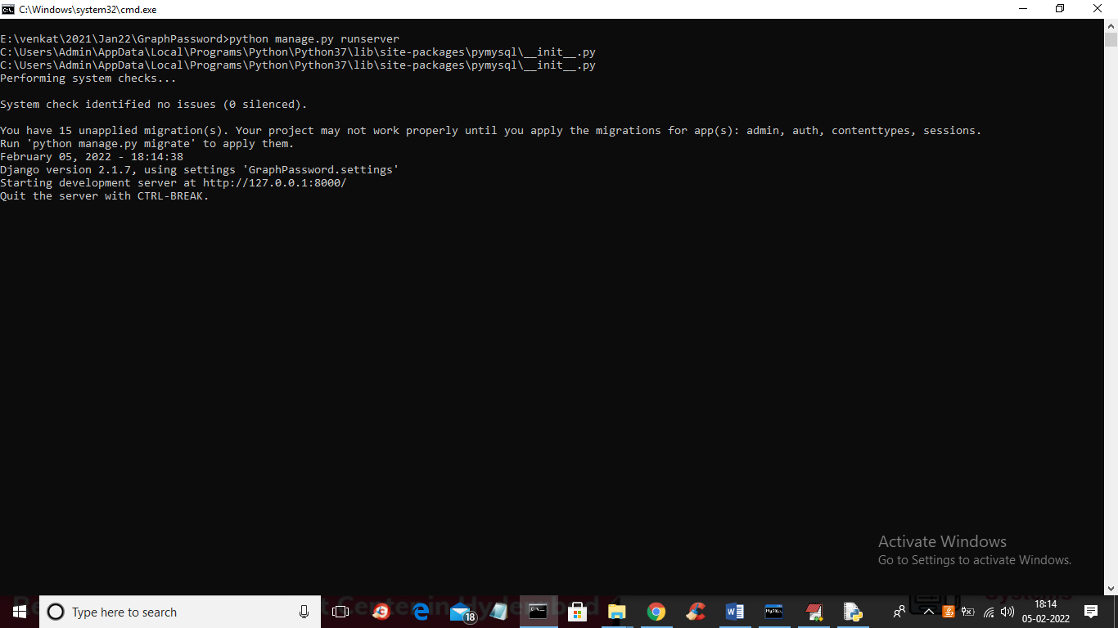
In above screen DJANGO server started and now open browser and enter URL as http://127.0.0.1:8000/index.html and press enter key to get below page
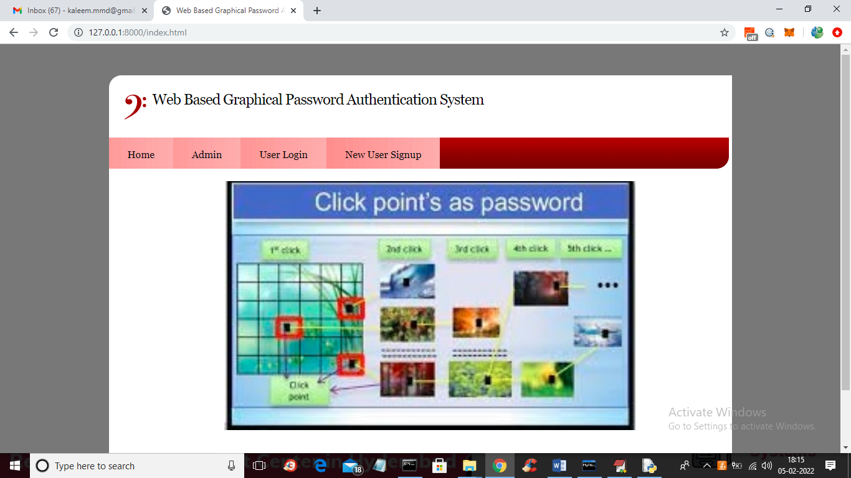
In above screen click on ‘New User Signup’ link to add new user details
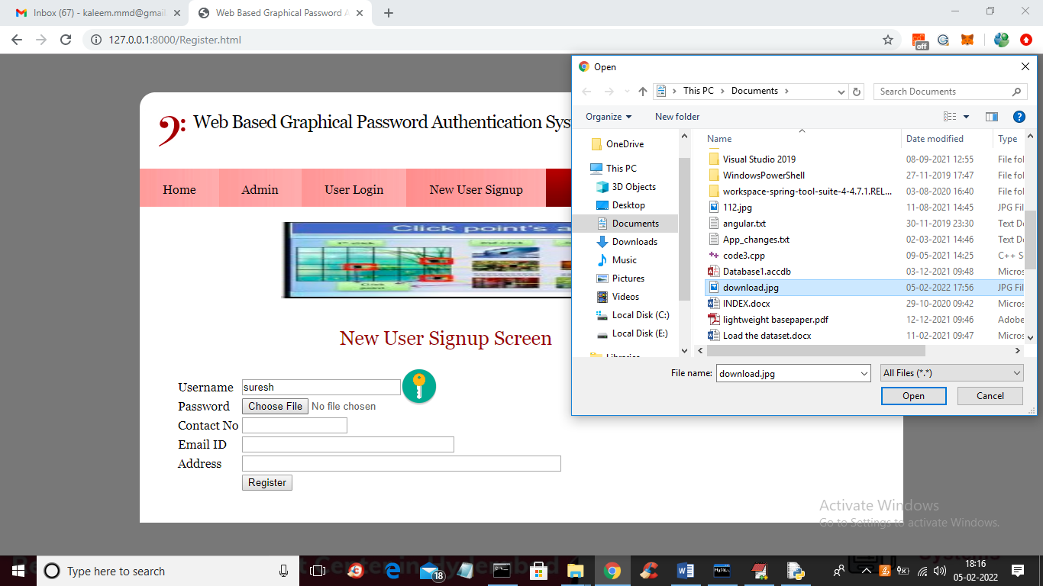
In above screen user is entering signup details and in place of password browsing and uploading image and then enter remaining details
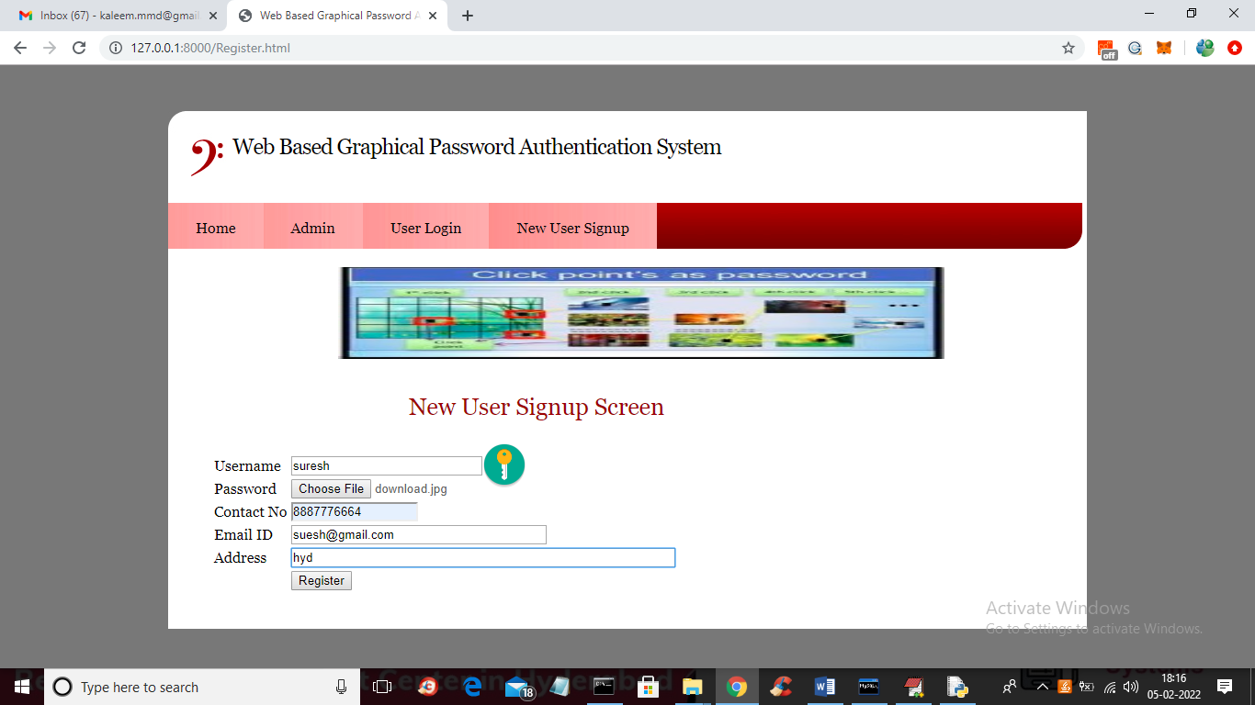
In above screen after entering all details click on ‘Register’ button to get below page with image
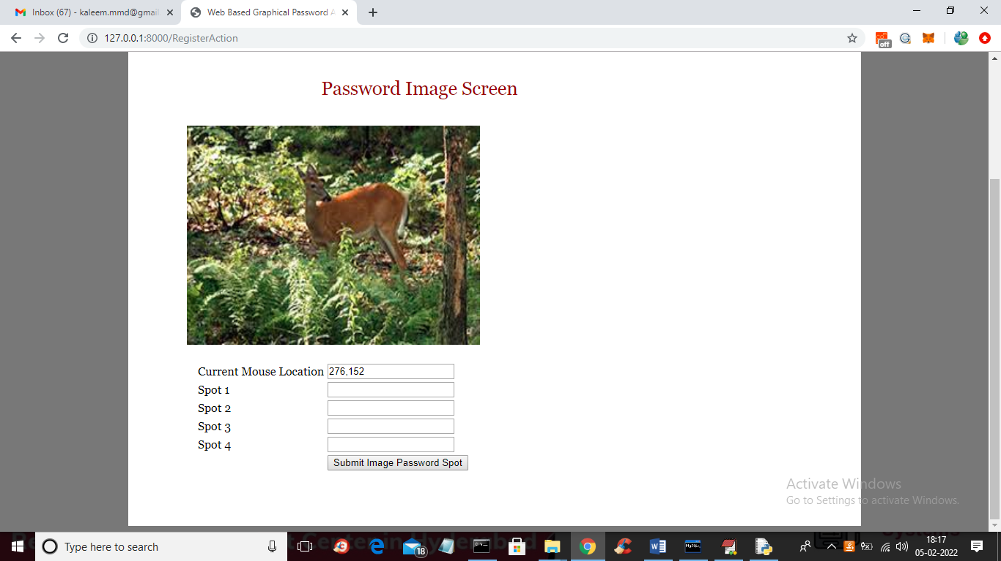
In above image user has to click on any part of the region then location will be added to text fields and first field will display the current location of mouse so you will know which point your mouse is at and u need to select 4 spot and then will get below screen
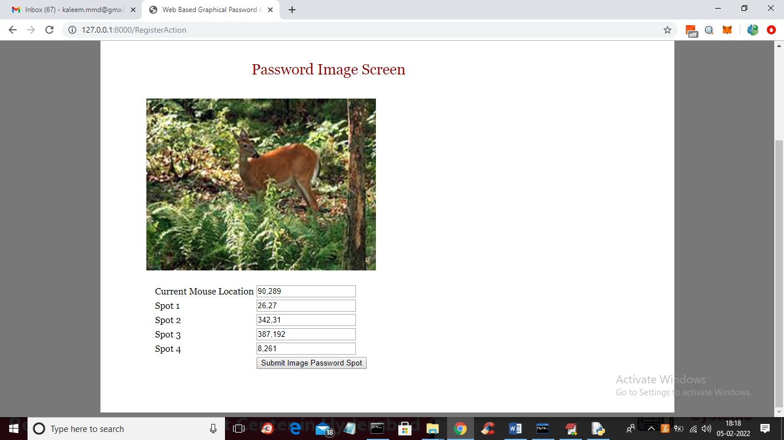
In above screen I selected 4 spots and all those X and Y selected values are filled in the text fields and then press button to get below page
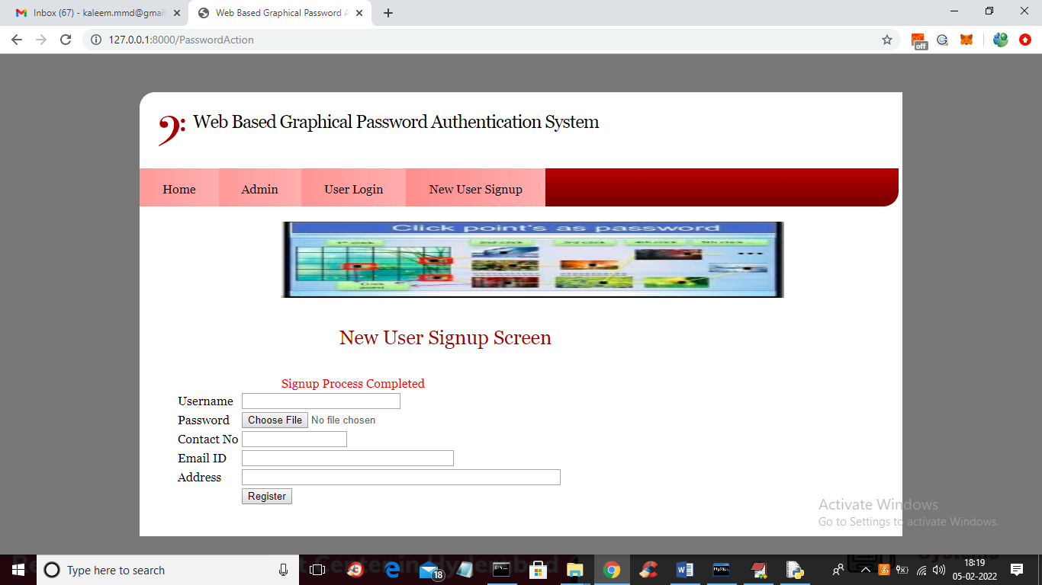
In above screen we got message as ‘signup process completed’ and now click on ‘Admin’ link to login as admin and view all user details
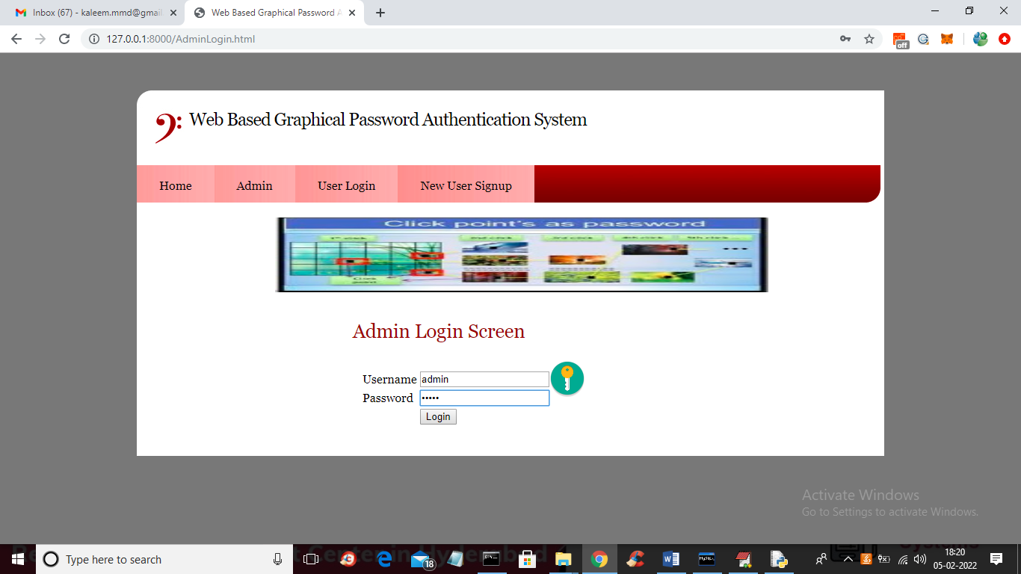
In above screen admin is login and after login will get below page
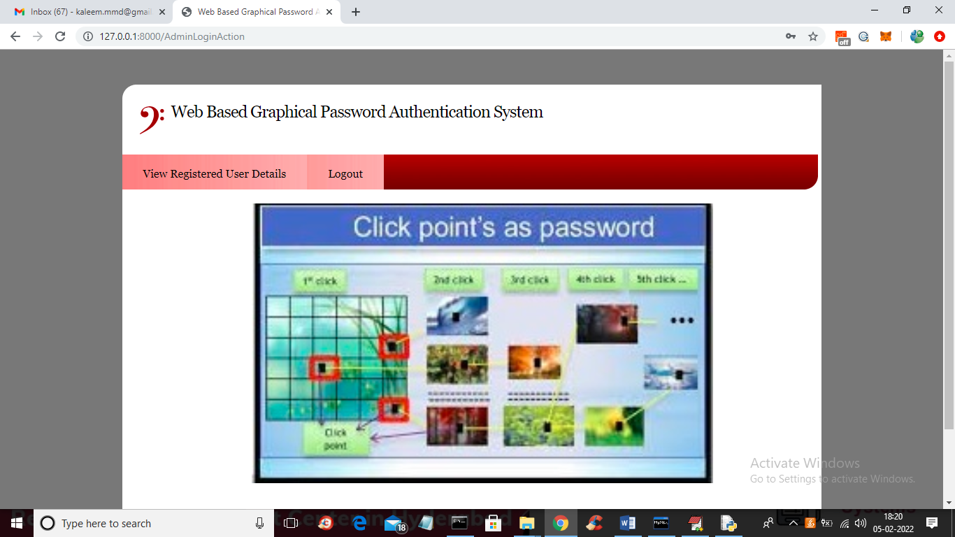
In above screen admin can click on ‘View Registered User Details’ link to get below page
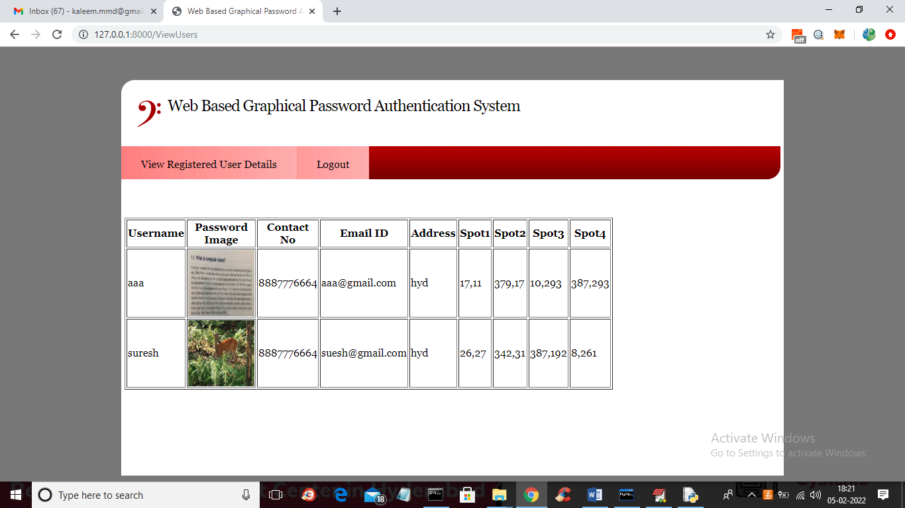
In above screen admin can see all users details such as username and password as image and selected 4 spots and now logout and login as user suresh
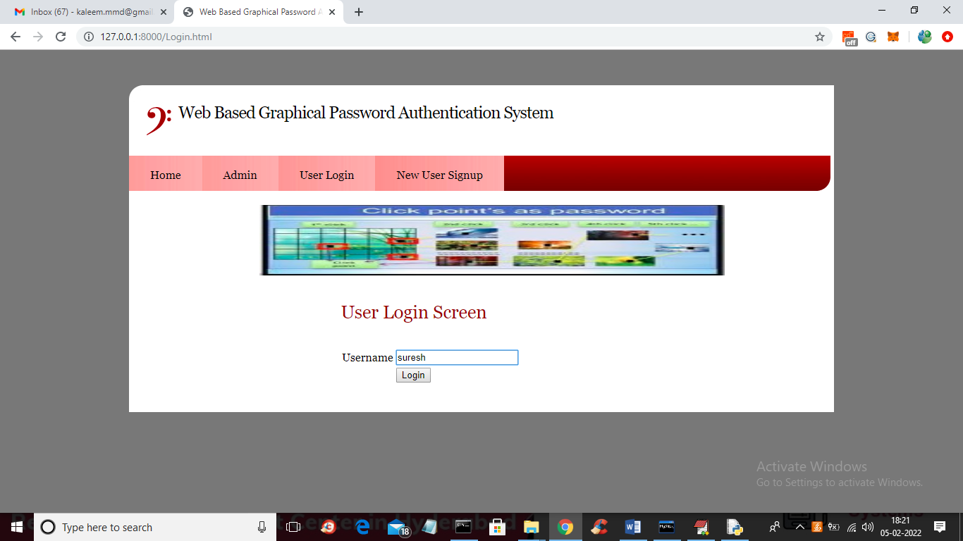
In above screen user is login by entering username and then press button to get image and to select spots like below screen
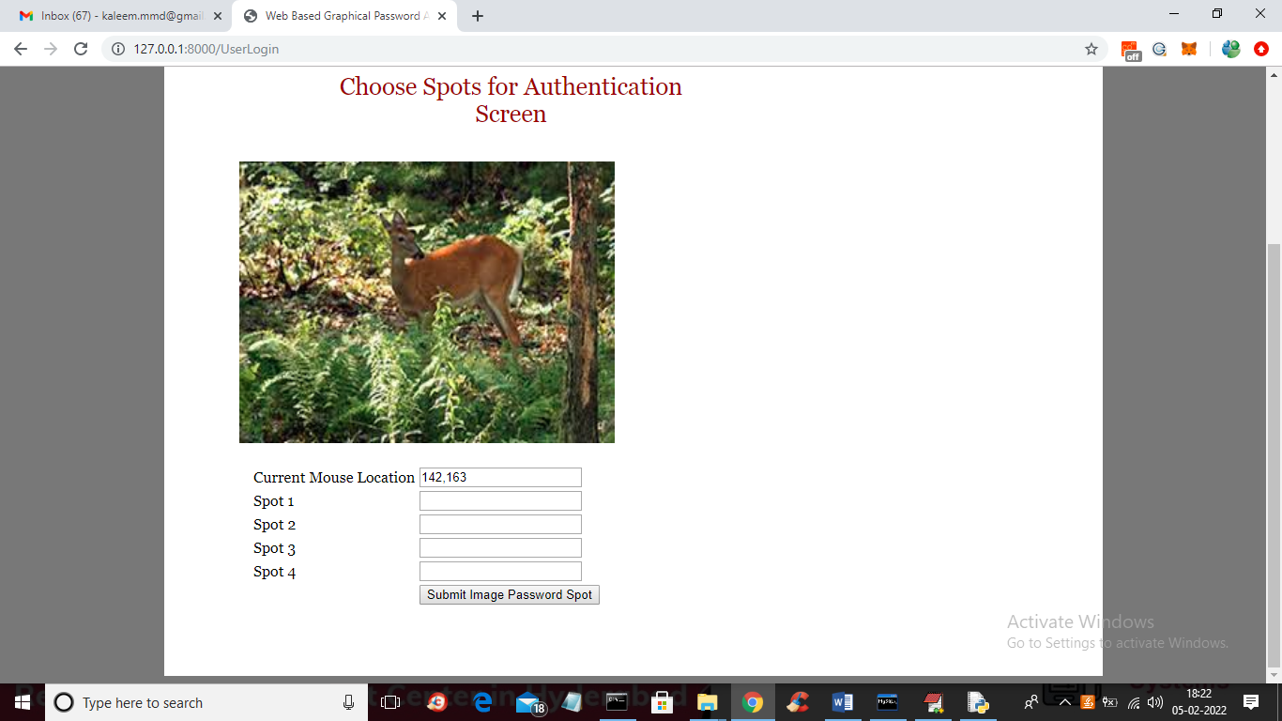
In above screen for login also user has to select 4 spots and then press button to authenticate
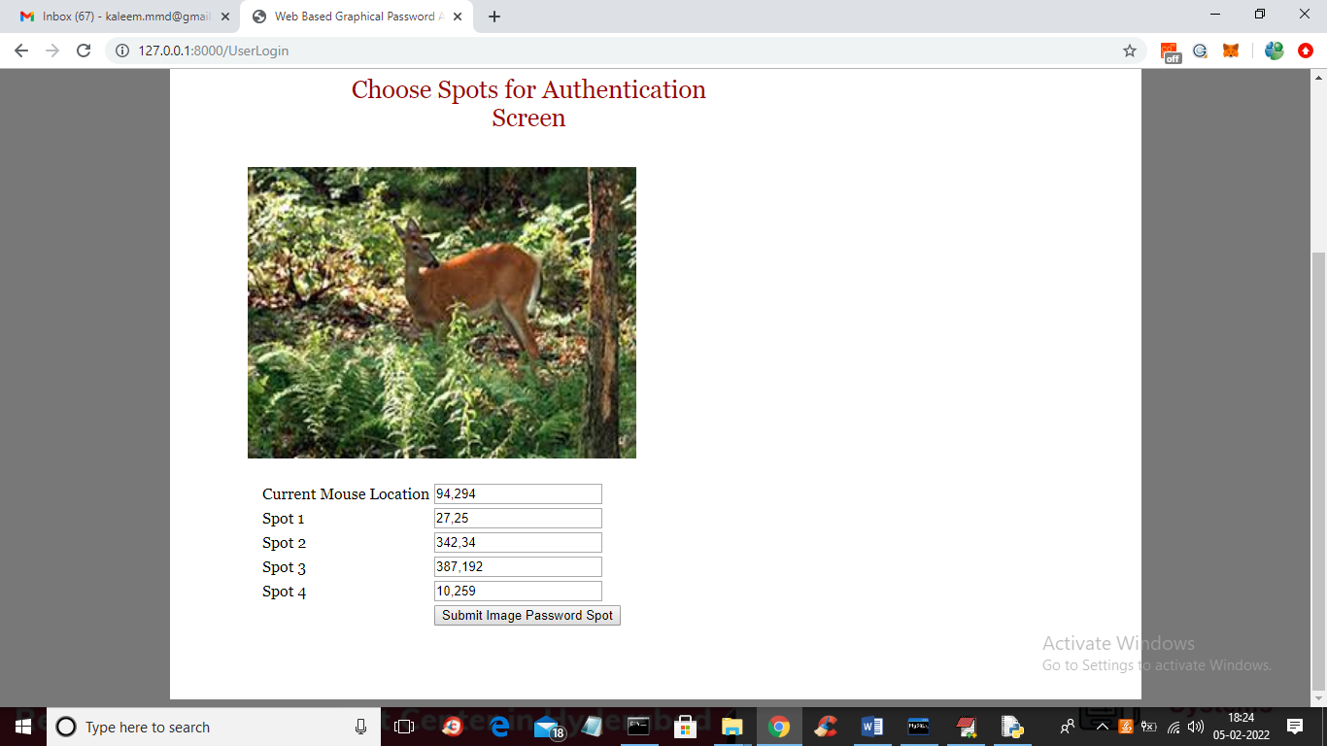
In above screen I selected values in range and then press button to get below screen and if given spots falls between correct password spots in database then user will get authenticated and get below screen
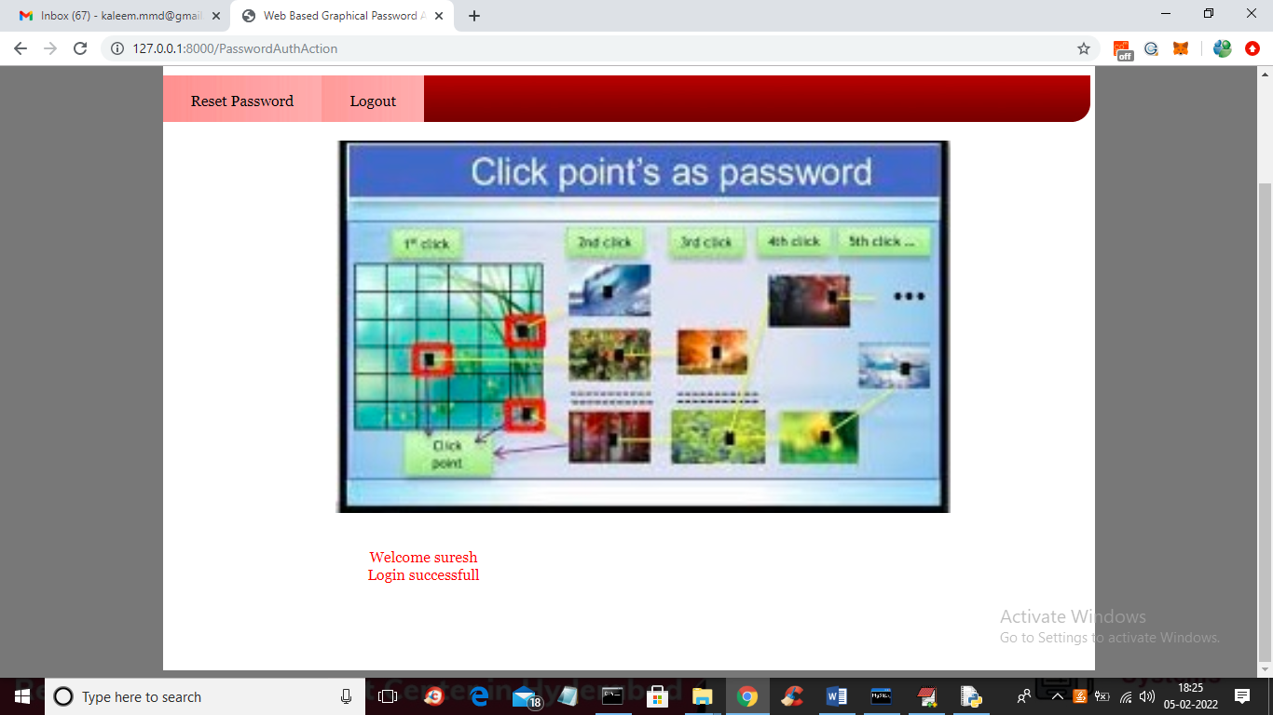
In above screen in red colour text we can see login is successful and if u give wrong details then authentication will get failed and if you want to reset password with new image and spots selection then click on ‘Rest Password’ link and repeat same steps.
NOTE: in any field if values are available then just delete those values from the field so new selected spot values can be appear

Fig. 5. Home Page of Graphical PasswordAuthenticator
The above image shows how the graphical password authenticator looks like. User can register an account from this home page and then can enter into his/her profile. The Registration section is secured with 2 layers of security. One is a textual password and another is a graphical one.
User can login to his/her profile by clicking the login button. The login page also includes 2 layers of security as mentioned above.

- CONCLUSION
To protect users digital property, authentication is required every time they try toaccess their account and data. Conducting the authentication process in public might result in potential shoulder surfing attacks. Using traditional textual passwords or PIN method, users need totype their passwords to authenticate themselves and thus these passwords can be revealed easily if someone peeks over their shoulder or uses video recording devices such as cell phones. To overcome this problem, we proposed a shoulder surfing-resistant authentication system based on graphical passwords.
- ACKNOWLEDGEMENT
The authors wish to express gratitude toward Principal Dr. Manoj George, Dr. Vinod P Vijayan, H.O.D, Computer Science Department for the proper direction, significant help, and supportive remarks during the editing.

- REFERENCES
- Wantong zheng, Chunfu Jia, CombinedPWD: A New Password Authentication Mechanism Using Separators Between Keystrokes: 2017 13th International Conference on Computational Intelligence and Security (CIS)
- Salisu Ibrahim Yusuf, Moussa Mahamat Boukar, User Define Time Based Change Pattern Dynamic Password AuthenticationScheme, 2018 14th InternationalConference on Electronics Computer
- Yang Jingbo, Shen Pingping, A secure strong password authentiction protocol, 2010 2nd International Conference on Software Technology and Engineering
- Hua Wang, Yao Guo, Xiangqun Chen, DPAC: A Reuse-Oriented Password Authentication Framework for Improving Password Security, 2008 11th IEEE High Assurance Systems Engineering Symposium
- Salah Refish, PAC-RMPN: Password Authentication Code Based RMPN, 2018 International Conference on AdvancedScience and Engineering (ICOASE)
- M Hamza Zaki, Adil Husain, M Sarosh Secure pattern-key based password authentication scheme2017 International Conference on Multimedia, Signal Processing and Communication Technologies (IMPACT)
- Vasundhara R Pagar, Rohini G Pise, Strengthening password security through honeyword and Honey encryptiontechnique, 2017 International Conference on Trends in Electronics and Informatics (ICEI)
- S. Sood, A. Sarje, and K. Singh, Cryptanalysis of password authentication schemes: Current status and key issues, in Methods and Models in Computer Science, 2009. ICM2CS 2009. Proceeding of International Conference on, Dec 2009, pp. 17..
- S. Gurav, L. Gawade, P. Rane, and N. Khochare, Graphical password authentication: Cloud securing scheme, in Electronic Systems, Signal Processing and Computing Technologies (ICESC), 2014International Conference on, Jan 2014, pp. 479483
- A. Bianchi, I. Oakley, and D.S. Kwon, The secure haptic keypad: A tactile password system, in Proceedings of the SIGCHI Conference on Human Factors in Computing System. CHI 10. New York, NY, USA: ACM, 2010, 10891092.
- E. von Zezschwitz, A. De Luca, and H. Hussmann, Honey, shrunk the keys: Influences of mobile devices on password composition and authentication performance, in Proceedings of the 8th Nordic Conference on Human-Computer Interaction: Fun, Fast, Foundational, ser. NordiCHI 14. New York, NY, USA: ACM, 2014, pp. 461470.

